EXECUTIVE SUMMARY

Rongjeng-Mangsang-Adokgre (RMA)
Meghalaya Logistics and Connectivity Improvement Project (MLCIP)

Submitted
to


Meghalaya Infrastructure Development Finance Corporation (MIDFC) Ltd.
House No. L/A-56, Lower Nongrim Hills,Top Floor,
Meghalaya Basin Development Authority (MBDA) Building,
Shillong East Khasi Hills, Meghalaya-793003

ESIA Somaning (Summary)

Project Rang·chanchapa (Project Introduction)
Meghalaya Logistics and Connectivity Improvement Project (MLCIP) an·chingni miksongrangko dakchakanina kam ka·a, chong·motgipa nangchongmot ong·a:
a) chin·apgipa road corridor-rangni jakkalna dal·gipa bikrang aro growth center-rangona connection-ko namatna; b) grong-level aro district-level logistics infrastructure aro seva-rangko namatna;
c) select agriculture aro horticulture product-rangna marketona reach ong·e jakkalna, cost aro samai-ko komiatna; aro d) East Meghalaya-o climate-resilient transport aro logistics-ko chusok ong·e chalna institution-rangni capacity-ko bilangna.
Proposed road-ara Meghalaya State ong·e janggi on·na skangonin dongachim, aro ROW existing drain-na chadengsa ong·a. Proposed RMA project road-ni total lambak 22 km ong·a. Road-ara Rongjeng–Mangsang Village (chainage 23+000)oni a·bacheng·e, Adokgre (chainage 44+000)ona soke bon·a, jepai project road chu·gimik bon·kam ong·a.

Niyam aro kanun-rang baksa meligrik ong·ani bynta
ESIA-ara ia niyam aro kanun-rang baksa meligrik ong·a:
- World Bank Environmental aro Social Framework (ESF)
- Environmental aro Social Standards (ESS 1–10)
- India Government aro Meghalaya Government-rang environmental niyam
- Labour, forest, biodiversity aro pollution control-rang kanun

Project-rang kam-chalna samai-suchi
Nang·ni set criteria aro conditions-rang baksa, MPWD civil works contract-ko eligible contractor-na debak ong·a. Contractor-na quality materials-ko pora jakkalna, nearest authorized source aro approved manufacturer-na laga debak ong·a. Construction process-rangni somai, prescribed standard-rang meet gipa equipment-ara use debak ong·a. Contractor-na construction schedule-rang baksa required manpower-ko mobilize debak ong·a. 22 km project road-rang construction period 24 month-rang baksa plan gipa ong·a.

Chong·ni pora environment-rang sthiti
Road corridor-rang soil sandy loam ong·a, well-drained aro moderately acidic ong·a, arangni region-rang high rainfall conditions-ina typical ong·a.
Water quality mostly fresh aro unpolluted ong·a, neutral pH-rang, sufficient dissolved oxygen-rang, low turbidity (monsoon-rang chadengsa except), aro low BOD/COD values ong·a. Industrial discharge nai, aro large-scale agricultural runoff-na water body-rang affect nai ong·a. Overall, water quality domestic use-ko baksa suitable ong·a, basic treatment-na pora use debak ong·a.
Ambient noise environment mostly quiet to moderately noisy ong·a, rural area-rang characteristics-ina baksa. Baseline noise level-rang CPCB limit-rang residential aro rural area-rang somai, day aro night, most location-ona meligrik ong·a.
Project corridor-rang air quality good to moderate ong·a, rural Meghalaya-rang characteristic-ina, industrial activity kom ong·a. Ambient concentration PM₁₀, PM₂.₅, SO₂, NO₂, aro CO generally National Ambient Air Quality Standards (NAAQS)-na meligrik ong·a.
Environment aro community-rang upor project-rang potential effect
Proposed road corridor-rang environment screening-ina sensitive receptors aro community assets alignment-rang pora dekha gipa ong·a. Several environmentally sensitive location-rang identify gipa ong·a, arangni: Chainage 31+100 (Right-Hand Side: LP School), Chainage 33+200 (Left-Hand Side: LP School), aro Chainage 39+200 (Left-Hand Side: Church).

Adverse impact-rang komiatna aro project implementation smooth ong·a baksa, appropriate mitigation measures propose gipa ong·a. Ni observation aro recommendation-rang summary table-ona dekha gipa ong·a.

Table: Observation-rang aro Corresponding Recommendation-rang
Sl. No. | Baksa debak kam aro step-rang | EIS Team-rang dekha gipa observation-rang | DPR-rang pora baksa debak mitigation input-rang
 | Design-nga pora baksa debak step aro arrangement-rang | Existing road ko very poor ong·a aro mostly earth road 18.5 km pora ong·a. Only 3.5 km paved road ong·a. Geological condition-rang physical observation-ina 2–3 m overburden, 5–8 m weathering aro baki rock ong·a. Road-ara partially plain aro partially hill-ona pass gipa ong·a. | • Road geometry-rang improvement, curve-rang convex mirror aro junction management road safety-baksa debak.  • Cross drainage structure-rang provision debak.
 | Environment-rang upor improvement aro positive step-rang | Environment sensitive location-rang:  - Chainage 31+100 (RHS: LP School).  - Chainage 33+200 (LHS: LP School).  - Chainage 39+200 (LHS: Church). | Settlement aro sensitive roadside development-rang pedestrian path aro crossing-rang provision debak.  • Accident-prone stretch-rang speed limit komiatna baksa cautionary sign board, proper light aro divider-rang provide debak.  • School, college aro weekly local market-ona traffic management measures advise debak.  • Commuter, student aro elderly person-rang road safety enhance debak, junction, bus stop aro settlement location-ona enhanced signage aro zebra crossing-rang provide debak.
 | Landslide prone area-rang safe aro stable ong·e baksa debak step-rang | Road-ara landslide/land slip prone area-rang dekha gipa ong·a | Identified landslide area-rang, enhanced design parameter-rang use debak, changing climate aro past disaster-rang pora dhor·si. DPR consultant-na pora Geotech specialist-ina consult debak aro landslide treatment plan provide debak advise gipa ong·a.
 | Construction aro labour camp-rang pora safe, organized aro environment-friendly ong·e baksa debak design step-rang | Labour Camp-rang location Nokma aro local community-rang pora consultation-ina decide debak ong·a. | -
 | Polluting material-rang leak komiatna aro control debak step-rang | Project-rang main potential polluting material-rang source lubricating oil spill/leakage aro construction activity-rang spoil material ong·a, arangni directly nai indirectly drainage aro open stream-ina soil aro groundwater-ona jabo pare. Contractor-nga use gipa lubricating oil, solvent aro fuel concrete nai brick building-ina store debak, arangni purpose-ina design gipa ong·a. | • Oil/fuel storage building well-ventilated, roofed structure aro impermeable floor-rang ong·a debak. Entranceway-ona berm integrate debak, arangni accidental oil/fuel spill/leakage-ona shallow holding tank-rang create debak. Fire extinguisher-rang, oil/fuel fire-lik suitable type-ara, storage building-ona aro bahar-ona position debak.  • Oil spill clean-up material (sorbent pad, loose sorbent material, etc.) storage building-ona clearly labelled container-ina rakhibak ong·a.  • Liquid waste management system install debak, arangni surrounding land aro water body-ona unacceptable impact nai ong·a. Labour camp drainage system carefully design debak, camp area flooding avoid debak aro discharge site-ona oil aro grease separator-ina pora pass debak.
 | Slope-rang stable aro erosion komiatna baksa debak step-rang | Existing road partially hill-ona aro condition-ina poor ong·a. | Proposed project partially hill-ona baksa, design measures-rang slope stabilization technique implement debak, arangni retaining wall, rock bolt aro geotextile use debak, landslide aro erosion-ona prevent debak.
 | Excavated soil aro construction waste-rang safe aro environment-friendly pora dispose debak plan-rang | Construction activity-rang somai muck generate debak ong·a. Muck disposal site-ara nok·a identify gipa ong·a. | DPR consultant-na propose gipa ong·a, Proposed Typical Cross Section existing Right of Way-ina accommodate debak (Geometric Design/Improvement-ina required ong·a). Additional land lagibo pare. Proposed location-rang details aro information 10 working days-rang pora concerned ESIA consultant-ina share debak ong·a, arangni land type aro nature identify debak.
 | Noise level-rang pora monitoring aro assessment debak process-rang | Noise modeling baseline condition-rang pora carry out debak ong·a. | Assessment noise barrier-rang lagibo nai aro avoid debak dorkar justify debak ong·a.
 | Road curve-rang safe aro smooth ong·e baksa debak design aro construction step-rang | Chainage 26+500-ona: Road safety-baksa curve improvement lagibo pare. | Road geometry-rang improvement, curve-ona convex mirror aro junction management provide debak, road safety-baksa.

Community aro social-rang pora dekha gipa observation-rang

Social screening-rang finding-rang table-ona dekha gipa ong·a:

Social screening-rang dekha gipa observation aro result-rang
S. No. | LHS/RHS | Chainage aro distance-rang baksa debak information | Centre line-ona distance meter-rang baksa debak information | Impact-rang category aro nature
 | LHS | 22+900 | 5.7 | Road-ara temporary house-rang
 | LHS | 24+610 | 5 | Road-ara temporary house-rang
 | LHS | 37+400 | 5.8 | Road-ara temporary house-rang
 | RHS | 28+000 | 5.5 | Road-ara temporary house-rang
 | LHS | 29+200 | 5.6 | Road-ara temporary house-rang

FPIC-3 suggestion by community of Rongjeng-Mangsang-Adokgre, RMA Road Date: -09-10-2025 Time: 1:00 PM
Venue: - Nongkongkil Community Hall, Near L.P School Location-1
Sr. No | Baksa debak information-rang: Particulars, Village Name aro Locality | Community-rang pora baksa debak suggestion nai query | Observation, note, or additional comment-rang | DPR-ona pora baksa debak compliance nai proposal-rang
1 | Nongkongkil village | Nongkongkil village-rang community-nga Bus Shed aro Storeroom construct debak baksa debak, Community Hall-ona, L.P. School-rang opposite-ona. |  | Bus Shelter aro Toilet Km 24+300-ona propose gipa ong·a.
2 | At Ch-24+000 (Approx) | Nongkongkil village-rang community-nga 3 different location-ona 3 Bus Shed construct debak aro 3 community toilet provide debak baksa debak, separate for boys aro girls. |  | Baksa nai debak ong·a
3 | At Ch-23+000 (Approx) | Community-nga 1 Bus Shed construct debak aro community toilet provide debak baksa debak, separate for boys aro girls. |  | Baksa nai debak ong·a.
4 | At Ch-26+000 (Approx) | Mowgru village-rang community-nga 1 Bus Shed construct debak aro community toilet provide debak baksa debak, separate for boys aro girls, water connection facility-ona lagibo. |  | Bus Shelter aro Toilet Km 25+400-ona propose gipa ong·a.

FPIC-3 suggestion by community of Rongjeng-Mangsang-Adokgre, RMA Road Date: -09-10-2025 Time: 4:00 PM
Venue: -Memilam Community Hall Location-2

Sr. No | Baksa debak information-rang: Particulars, Village Name aro Locality | Community-rang pora baksa debak suggestion nai query | Observation, note, or additional comment-rang | DPR-ona pora baksa debak compliance nai proposal-rang
1 | At Ch-37+000 (Approx) | Maudipara village-rang community-nga 2 Bus Shed construct debak aro 2 community toilet provide debak baksa debak, separate for boys aro girls, water connection facility-ona lagibo. |  | Bus Shelter aro Toilet Km 37+000-ona propose gipa ong·a.
2 | At Ch-38+000 (Approx) | Memilam village-rang community-nga 1 Bus Shed construct debak aro 1 community toilet provide debak baksa debak, separate for boys aro girls, water connection facility-ona lagibo. |  | Bus Shelter aro Toilet Km 38+500-ona propose gipa ong·a.
3 | At Ch-44+000 (Approx) | Thingla village-rang community-nga 1 Bus Shed construct debak aro 1 community toilet provide debak baksa debak, separate for boys aro girls, water connection facility-ona lagibo. |  | Bus Shelter aro Toilet Km 42+750-ona propose gipa ong·a.
4 | At Ch-32+000 (Approx) | Jajil village-rang community-nga 1 Bus Shed construct debak aro 1 community toilet provide debak baksa debak, separate for boys aro girls, water connection facility-ona lagibo. |  | Bus Shelter aro Toilet Km 32+150-ona propose gipa ong·a.
5 | At Ch-37+000 (Approx) | Ch-37+000-ona community-nga 1 waiting area construct debak baksa debak market shed-ona, aro toilet provide debak, separate for boys aro girls. |  | Previous entry-rang baksa repeat gipa ong·a.

GRM-rang process aro steps-rang diagrammatic representation
Nangni flowchart-rang show gipa ong·a two-tier grievance redressal mechanism, responsibilities aro resolution-rang timelines-rang baksa debak.
Project site-ona grievance redressal-rang baksa debak level | Responsibility: VECs & Headman  Timeline: Resolution within 15 days  If unresolved → Escalate to PMU (Tier II)
State level-ona, PMU-rang grievance redressal-rang baksa debak level | Responsibility: Secretary Planning, Chief Engineer,  Project Director, Social Expert  Timeline: Resolution within 15 days

Grievance Redressal Mechanism-rang process, responsibilities aro resolution-rang steps-rang baksa debak.
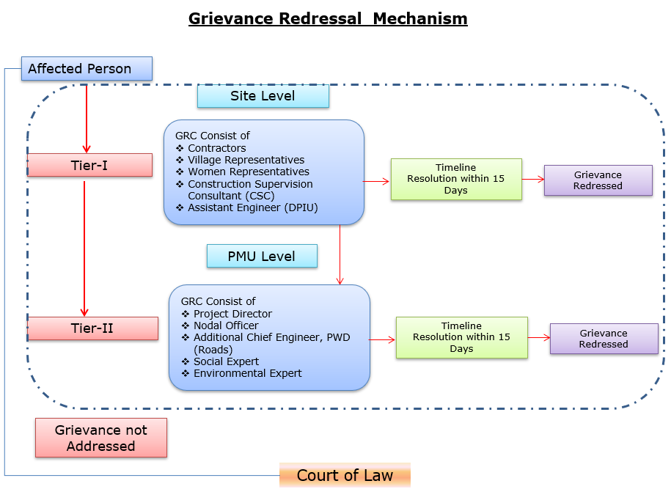
Grievances submit debak baksa contact information-rang baksa debak.
Baksa debak pora detail nai explanation | Baksa debak pora contact information, phone number, email, nai address
Company: | PWD, Meghalaya
To: | Chief Engineer-cum-Nodal officer
Address: | HV9P+GFJ, Lachumiere, Shillong, Meghalaya 793001
E-mail: | esmlcip@gmail.com
Website: | http://megpwd.gov.in/contacts.html
Telephone: | Tel: 0364-3572466
Fax: | -

Project-rang governance aro overall institutional structure-rang baksa debak.
Ka kam-rangkam ka dakgipa donggipa jylla Government of Meghalaya (GoM)-ni donggipa institutional architecture baksa meligrikgen, aro Sixth Schedule-ni niyam rangsani, janggi jatni hokrang (tribal autonomy)-ko dakchakgen.
MIDFC, je project-ni sabsi kamrangko dakchakgipa aro taka-paisani bynta nanggipa ong∙a, ua project-ni holder aro lead implementing agency ong∙gen.
MPWD-de civil works (rasta, bridge aro ropeway)-rangko dakchakgen, aro Department of Agriculture (DoA) aro MBMA-rangde agrologistics aro community components-rangko kam ka∙gen.
MIDFC-PMU-ni rangko project management aro coordination-rangko dakchakgen, World Bank-ni procedure-ko experience napha officers-ni through.
PMC, je team-ni expert aro consultant-rangni Team Leader-ni ong∙a dakchakgen, project activities-rangko technical support-ka∙gen, je implementing agencies-ni skill set-ni napha dang∙a.
CSC-ni construction supervision-ka∙gen.
PMC/CSC aro information collect aro document-ka∙gen-rangni aid ka∙gen.
Project implementation structure-ko figure-ni dang∙a dakchak:
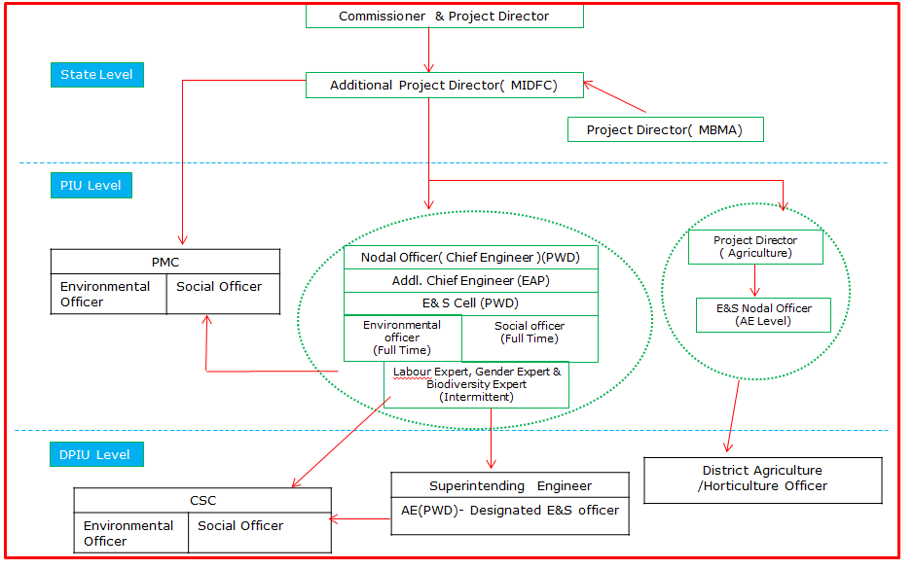
Figure: Project Kam-rangkam Organogram
Khutcha
ESIA-ni phayrang dakchakni phangni ni nangni gital:
• Proposed project-ni rasta-ni traffic flow-ni dakchakni aro motor vehicle aro pedestrian-ni safe aro smooth mobility-ka∙gen. Proposed road improvement-ni travel time-ni farthest section-ni rasta-ni dang∙a market-ni gi hour-ni 1 hako 30 minutes-ni mel∙a dakchak. Project-ni importance-ni trade aro commercial activity (public transport-ko include) East Garo Hills aro North Garo Hills-ni district-ni encouragement-ka∙gen.
• Environmental aro social impact assessment-ni World Bank ESF aro National & State regulations-ni meligrikgen. Pre-construction, construction aro operation phases-ni dang∙a potential impacts-ni dakchakni gital.
• Proposed project alignment-ni Wildlife Sanctuary/National Park/Biosphere Reserve/Tiger Reserve-ni dang∙a pasal-ni dakchak∙a.
• Project site-ni 0.5 km-ni dang∙a ASI Protected monuments-ni dakchak∙a.
• Approximately 20 trees existing Right of Way (RoW)-ni dang∙a road-ni sides-ni dakchakni. Tree felling-ni ecological impact-ka∙gen mitigation-ni, compensatory afforestation-ni applicable environmental regulations aro guidelines-ni meligrikgen dakchak∙a.
• Project road-ni construction activities-rangko environmental aro social impacts-ni dang∙a dakchakni; culturally important sites-ni proximity-ni (community center, church, school etc.) aro Project-Affected Persons (PAPs)-ni access-related issues-ni potential effect-ni dakchakni.
• Stakeholder Consultations-ni conducted dakchakni, proposed project-ni perception-ni assess-ka∙gen. Consultations-ni outcome-ni dakchakni, people-ni project-ni support-ka∙gen, karon road conditions aro connectivity-ni improve-ka∙gen. Tangni road safety measures; road furniture’s (streetlights, signage, speed breaker etc.) aro loss-of-assets-ni proper compensation-ni require-ni raised-ka∙gen.
• Occupational health aro safety measures-ni workers aro local community-ni ensure-ka∙gen, comprehensive Labour Management Plan (LMP)-ni prepare aro implement-ni through, World Bank Environmental and Social Standard ESS2 on Labor and Working Conditions-ni meligrikgen.
• Mitigation measures-ni environmental aro social monitoring-ni program-rangko construction aro operation phases-ni dakchakni assure-ka∙gen; implementation-ni confirm-ka∙gen aro environmental aro social conditions-ni stipulated or protected-ni check-ka∙gen. Observation on-site aro off-site, document check, workers aro beneficiaries-ni interview aro remedial action-ni requirement-ni contractor-ni MPWD-ni report-ka∙gen.
• ESMP-ni bidding document-ni include-ka∙gen, contractual clauses-ni project construction aro operation (maintenance period)-ni environment aro social impact safeguard-ni ensure-ka∙gen.
• Project-level aro construction stage-level Grievance Redress Mechanism (GRM)-ni form-ka∙gen, affected parties-ni feedback, suggestions aro complaints receive aro address-ka∙gen, construction aro operation stage-ni.
• Prepared ESMP-ni Contractor aro MPWD-ni assist-ka∙gen Environmental aro Social impacts mitigate-ka∙gen aro proposed project-ni environmentally sound execution-ni guide-ka∙gen.

Capacity building and training

Environmental aro Social Management Plan (ESMP)-ni implementation aro monitoring-ni capability-ni improve-ka∙gen, structured training programs-ni contractor aro project personnel-ni gi sabsi conduct-ka∙gen dakchakni recommend-ka∙gen.

Training-ni regulatory requirements-ni compliance ensure-ka∙gen, awareness improve-ka∙gen aro environmental aro social (E&S) risks-ni manage-ka∙gen competence build-ka∙gen.

On-Boarding Phase
a. Induction Training
• Sabsi personnel-ni work start-ka∙gen ni mandatory.
• Contractor-ni Environmental aro Social Management Plan (C-ESMP), relevant national aro international Environmental, Social, Health aro Safety (ESHS) regulations aro good practices-ni cover-ka∙gen.

b. Specialized Training

• Personnel-ni specific roles-ni (e.g., environmental officer, safety officer, waste management supervisor) assigned-ka∙gen tailored training.
• Mobilization stage-ni deliver-ka∙gen, assigned responsibilities-ni readiness ensure-ka∙gen.

Implementation Phase
- Ongoing Toolbox Talks:
Daily aro weekly conduct-ka∙gen, evolving risks address-ka∙gen, safety practices reinforce-ka∙gen aro workers-ni continuous awareness maintain-ka∙gen.
- Supplemental Training:
Incident-hako pare or new risks identify-hako pare provide-ka∙gen. Recurrence prevent-ka∙gen aro workforce-ni new safety/environmental requirements-ni updated rakha∙gen.
- Routine Quarterly Training:
Contractor-ni every three months organize-ka∙gen:
o E&S compliance status aro progress review-ka∙gen.
o Previous quarter-ni lessons learned share-ka∙gen.
o Identified gaps aro challenges address-ka∙gen action plans develop-ka∙gen.
o Sub-project E&S objectives-ni alignment ensure-ka∙gen aro continuous improvement promote-ka∙gen.

Outcomes of the stakeholders

Rongjeng–Mangsang Adokgre road-ni FPIC process-ni community engagement progressively strengthen-ka∙gen aro final consent-ni dakchakni gital.

FPIC-I meetings-ni dang, community members-ni land acquisition, tree cutting aro vegetation clearance, utilities shift, aro construction-related disturbances (noise aro dust)-ni concerns raise-ka∙gen. Response-ni, project team-ni assure-ka∙gen, ESIA, ESMP, RAP aro IPDP-ni mitigation measures-ni through impacts-ni address-ka∙gen, environmental aro social impacts minimize-ka∙gen aro consent-based land acquisition ensure-ka∙gen. Community-level Grievance Redressal Mechanism (GRM)-ni establish-ka∙gen, concerns-ni promptly address-ka∙gen aro community participation continuous ensure-ka∙gen.

FPIC-II meetings-ni dang, community members-ni minor land loss, common property resources aro non-title holders-ni impacts, construction-related pollution, labour influx, temporary access disruptions aro vulnerable aro hillside areas-ni risks raise-ka∙gen. Project team-ni ESIA, ESMP, RAP aro IPDP-ni mitigation measures propose-ka∙gen, ha·ni voluntary land donation household holdings-ni 10%-ni limit-ka∙gen, protective structures provide-ka∙gen, pollution aro labour impacts manage-ka∙gen aro camps aro waste disposal-ni careful site selection-ka∙gen. Community inputs-ni DPR-ni include-ka∙gen ensure-ka∙gen, active Grievance Redress Mechanism (GRM)-ni support-ni aro dakchakni gital.

FPIC-III-ni dang, community members-ni private aro community land-ni requirement, construction-related risks (noise, air aro water pollution), labour influx aro social safety concerns (specially women aro children)-ni issues raise-ka∙gen. Communities-ni supporting infrastructure-ni need highlight-ka∙gen, ha·ni bus waiting sheds, public toilets, community storerooms aro water supply connections. Response-ni, project authorities-ni assure-ka∙gen, land only written consent-ni gi take-ka∙gen, impacts construction-ni appropriate mitigation measures-ni through manage-ka∙gen, joint site verification villagers-ni gi do-ka∙gen aro grievances-ni Grievance Redress Mechanism (GRM)-ni through address-ka∙gen. Community demands formally record-ka∙gen aro consent granted-ka∙gen, road improvement aro proposed community facilities-ni dang.

Resettlement Action Plan (RAP)

Resettlement Policy Framework (RPF)-ni gi meligrik, project-ni social impacts avoid aro minimize-ka∙gen measures adopt-ka∙gen, careful design aro existing RoW-ni use-ka∙gen.
Continuous consultations conduct-ka∙gen aro functional GRM-ni ensure-ka∙gen, concerns-ni timely resolve-ka∙gen. Sabsi entitlements RPF-ni meligrik provide-ka∙gen.
Road section-ni identified impacts-ko basis-ni, detailed site-specific Resettlement Action Plan (RAP) prepare-ka∙gen, ha·ni final entitlements, mitigation measures, implementation arrangements aro monitoring framework outline-ka∙gen, aro civil works start-hako pare implement-ka∙gen.

